Excel Assignment – 9

1. What are the different margins options and do we adjust the margins of

the excel worksheet?

Ans-

In Excel, margin refers to the distance between the edge of the page and the printed content. There are four margin options in Excel:  
\*Top margin: This is the distance between the top edge of the page and the beginning of the printed content.

\*Bottom margin: This is the distance between the bottom edge of the page and the end of the printed content.

\*Left margin: This is the distance between the left edge of the page and the beginning of the printed content.

\*Right margin: This is the distance between the right edge of the page and the end of the printed content.

Adjusting the margins can be helpful when you need to fit more content on a page or when you want to adjust the layout of your worksheet when printing.

2. Set a background for your table created.

Ans-

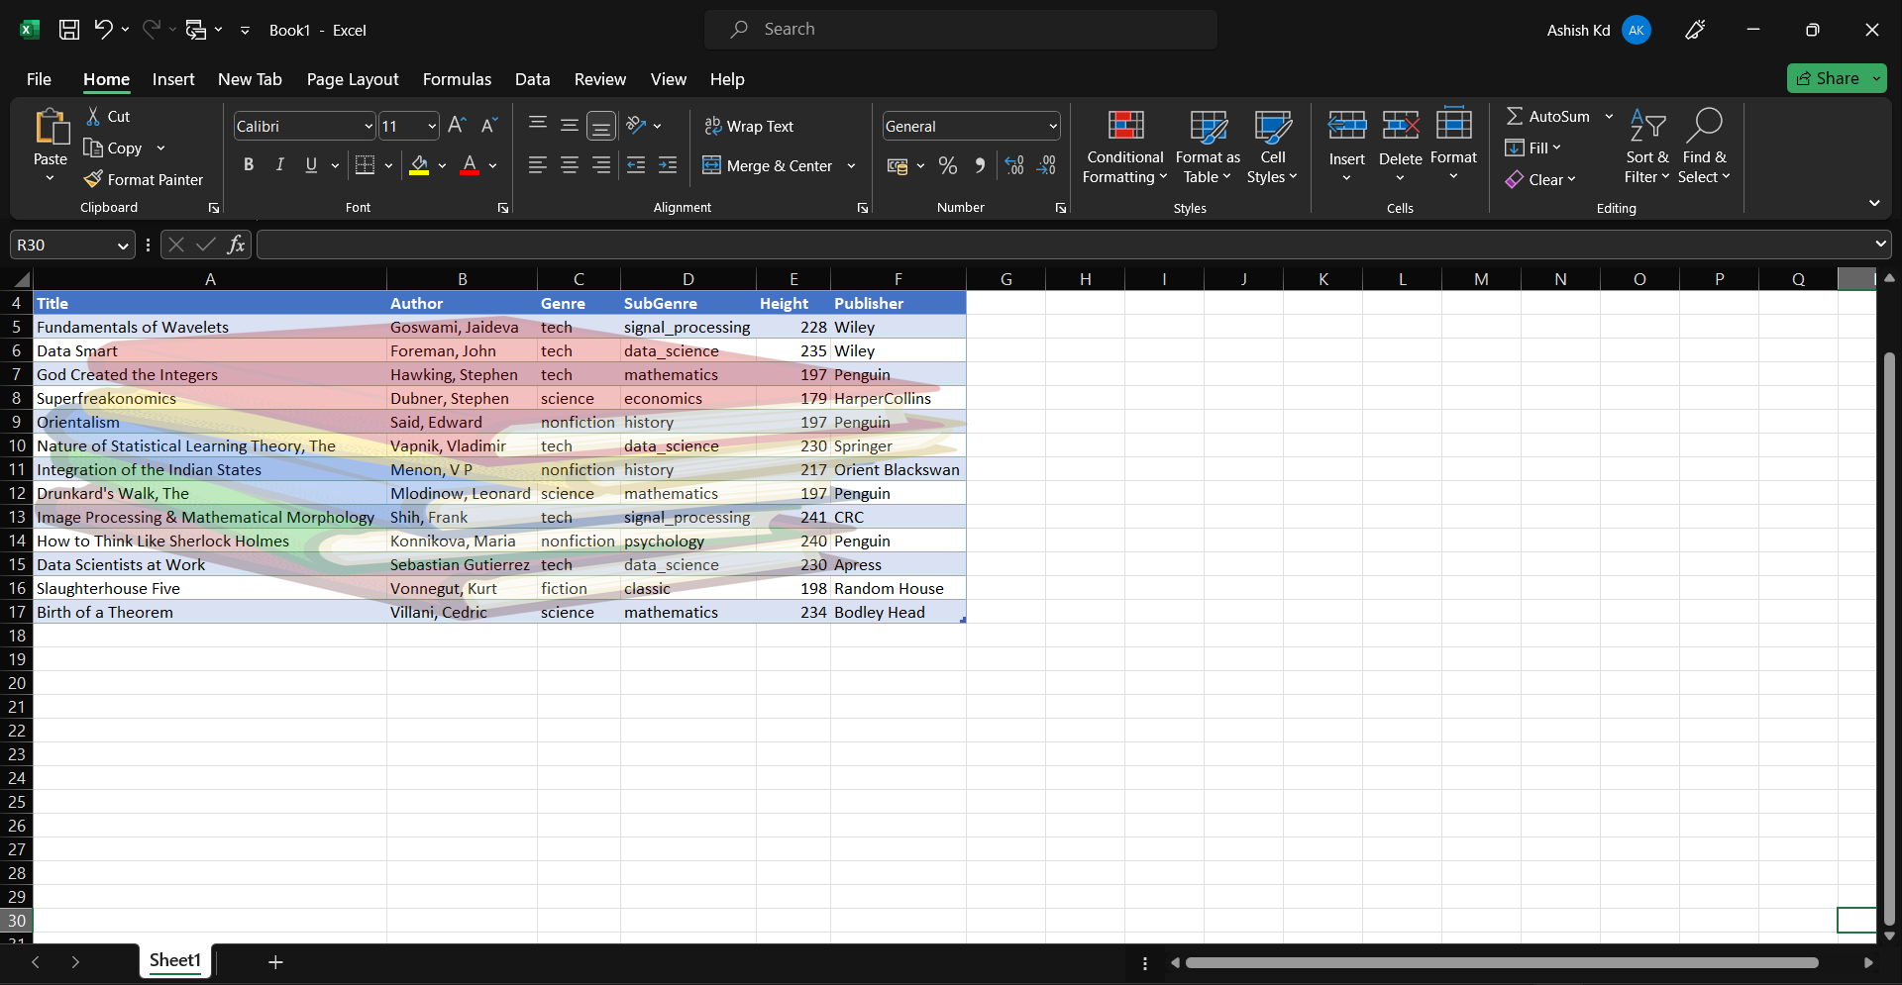

3. What is freeze panes and why do we use freeze panes? Give

examples.

Ans-

Freeze Panes is a feature in Microsoft Excel that allows you to lock certain rows or columns in place, so that they remain visible on the screen while the rest of the worksheet scrolls.

The primary purpose of using Freeze Panes is to keep important information, such as column or row headers, visible and accessible as you work with large amounts of data. This feature can also make it easier to navigate through long spreadsheets or tables, allowing you to keep your orientation and context within the data.

Here are some examples of when you might want to use Freeze Panes:

\*When working with a large table of data, you may want to freeze the header row or column so that it remains visible as you scroll through the data.

\*When creating a dashboard or summary report, you may want to freeze the first few rows or columns that contain key information, so that it is always visible to the user.

\*When comparing data from two different parts of a large worksheet, you may want to freeze both the header row and the leftmost column, so that you can easily compare the data in each section.

4. What are the different features available within the Freeze Panes

command?

Ans-

In Excel, the Freeze Panes command has several features that allow you to customize which rows or columns are frozen and how they are frozen. These features include:

\*Freeze Top Row: This option allows you to freeze only the top row of the worksheet, which can be useful if you have column headings or labels that you want to keep visible as you scroll through the rest of the data.

\*Freeze First Column: This option allows you to freeze only the first column of the worksheet, which can be useful if you have row headings or labels that you want to keep visible as you scroll horizontally through the table.

\*Freeze Panes: This option allows you to freeze both rows and columns based on the active cell`s position. For example, if you select cell B2 and choose Freeze Panes, both row 1 and column A will be frozen, so that they remain visible as you scroll through the rest of the data.

\*Unfreeze Panes: This option allows you to unfreeze any rows or columns that have been frozen using the Freeze Panes command. This can be useful if you no longer need to keep certain rows or columns in view.

\*Freeze Multiple Rows or Columns: In addition to freezing the top row or first column, you can also freeze multiple rows or columns by selecting the row or column below or to the right of the rows or columns you want to freeze, and then choosing Freeze Panes.

\*These features provide you with a variety of options for customizing which rows or columns are frozen, and how they are frozen, depending on your specific needs and preferences when working with large amounts of data in Excel.

5. Explain what the different sheet options present in excel are and what

they do?

Ans-

In Microsoft Excel, there are several sheet options available that allow you to customize and manage the worksheets in your workbook. Here's an overview of the most common sheet options and what they do:

-With Rename Sheet, you can give a name to a worksheet to make it easier to identify and remember its contents.

-Move or Copy Sheet allows you to copy or move a worksheet within the same workbook or to another workbook.

-Hide Sheet allows you to hide a worksheet so that it isn't visible in the workbook window. Unhide Sheet, on the other hand, lets you unhide a hidden sheet.

-Protect Sheet enables you to restrict access to a worksheet by setting a password and choosing the specific elements of the sheet that you want to protect.

-Insert Worksheet allows you to add a new sheet to the workbook.

-Delete Worksheet enables you to remove a worksheet from the workbook.